**George Mason University**

**Cybersecurity Engineering (CYSE) 492/493 Two-Semester Senior Design Capstone**

**Request for Proposal Template**

Rev June 24, 2019

**Note for Sponsor Companies and Organizations**: Please populate the **[Customer Input]** sections below. The other sections are intended as boilerplate or illustrative content, only make changes or updates if desired. The intent of this document is to:

* Provide the necessary information for Student Teams to understand the project and develop a Proposal
* Minimize the amount of input required from Sponsors.

**Request for Proposal**

Lockheed Martin Packer/Loader Project (Scamander’s Suitcase)

Matthew Murray, matthew.m.murray@lmco.com; Steve Kyle, steven.t.kyle@lmco.com; Austin Keeley, austin.t.keeley@lmco.com

**Points of Contacts:** Matthew Murray, matthew.m.murray@lmco.com; Steve Kyle, steven.t.kyle@lmco.com; Austin Keeley, austin.t.keeley@lmco.com

**Date:** August 9, 2019

Table of Contents

1.0 Executive Summary 2

2.0 Statement of Work 2

3.0 Objectives 2

4.0 Customer Provided Materials and Information 2

6.0 Project Deliverables 2

7.0 Terms and Conditions 3

7.1 Work Location 3

7.2 Best Effort Basis 3

7.3 Handling of Restricted Data 3

8.0 Proposal Guidelines and Requirements 4

Part 1 Technical Proposal 4

Part 2 Cost and Management Proposal 4

Appendix A Customer’s Technical Specifications 9

# 1.0 Executive Summary

Lockheed Martin (LM) Space, the Sponsor, provides large scale and complex systems to the US Government and other customers. Delivery of various files and executables to remote systems is an area of concern for Cybersecurity risks to our customers.

This project facilitates the exploration and development of methods to securely deliver files, executables, updates and data to remote systems. To that end, the Sponsor desires a packer/loader tool capable of performing compression and encryption capabilities on binary executables.

# 2.0 Statement of Work

The Supplier shall utilize software engineering and development practices and skills, as well as compression and encryption methods and techniques to produce a software tool, deliverable to LM, which can perform compression and then encryption operations on files and binary executables. The tool should specifically include the ability to handle the Portable Executable (PE) file format. Unique compression and encryption mechanism should be utilized in the development of the tool. The loader is to be a separate process that will decrypt the file(s) and then output them based on parameters that are configurable or run any executables in memory as a separate thread/process.

# 3.0 Objectives

The objectives for this project can be enumerated as follows:

* Required
  + Ability to compress and encrypt a Windows based binary executable
  + Encryption should be password based
  + Portable Executable (PE) file format binary executables must be supported
  + Compression/Encryption (Packer) capability must output to a single file
  + Packer must be able to support dynamic linking against libraries
  + Loader must be able to take Packer output and decrypt it
  + Loader must be able to output Packer file contents based on user defined, configurable parameters
  + Loader must be able to identify when Packer file contents are executables and run them
  + Running of executables by the Loader capability must be configurable, allowing user to toggle between an automatic run and a prompt during decryption/decompression
  + Loader must run executables in memory as a separate thread/process
* Desired
  + Compression and encryption of multiple files at a time to a single file
  + PE32+ file format binary executables supported
  + Loader never touches disk (e.g. everything happens in memory: decryption, decompression, and execution)
  + Packer supports both static and dynamic linking against libraries
  + Ability to also run in Linux/compress and encrypt a Linux based binary executable
  + ELF file format binary executables supported
  + Ability to also run in macOS/compress and encrypt a macOS based binary executable
  + Mach-O file format binary executables supported

# 4.0 Customer Provided Materials and Information

There are no unique hardware, software or data needs for this project. All software to support development activities should be available open source. Technical skills needed for this project include software development (C/C++ programming), and an understanding of encryption and compression techniques.

# 6.0 Project Deliverables

The contractor shall generate a project plan and propose deliverables that are appropriate for the project.

The following items must be included in this project.

* CLIN-1 (Contract Line Item Number 1) Customer Reporting “Quad -Pack”
* CLIN-2 Weekly Activity/Time Sheet
* CLIN-3 Color Team Briefing
* CLIN-4 Proposal (as a response to this RFP)
* CLIN-5 Design Review Briefing
* CLIN-6 Poster Paper
* CLIN-7 Encryption and Compression Design and Techniques Report
* CLIN-8 Final Report and Team Presentation
* CLIN-9 Product Specifications
* CLIN-10 Packer/Loader Source Code and Completed/Compiled Tool

# 7.0 Terms and Conditions

## 7.1 Work Location

Projects will be performed at George Mason University, Fairfax, VA, unless other arrangements have been negotiated. The student team is encouraged to visit the contractor provided their travel authorization is pre-approved by the class instructor.

## 7.2 Best Effort Basis

This work scope is to be performed on a best effort basis.

## 7.3 Handling of Restricted Data

Students, faculty, and administration are prohibited from signing any Intellectual Property agreements or Non-Disclosure agreements. These are University policies and there are no exceptions. No project work may include elements that are deemed For Official Use Only, Proprietary, Sensitive, or Classified. Posters will be publicly displayed and Project Notebooks will be publicly available. The Sponsor has the right to specify that their project team be comprised of US citizens; however, this does not imply allowance of Import/Export restricted information flow. Students nor faculty nor administration can receive ITAR restricted information or data. Should a company require approval of the Poster or other materials before public display, it is the responsibility of the Sponsor to ensure that such approval is secured in a proper and timely fashion and according to the requirements of the Sponsor's firm. Sponsoring companies must assume widespread discrimination of provided technical and project information. This includes other students, faculty, administration and even competitors in the marketplace as this is a totally open project. In any event, GMU shall be held harmless for the public display of project materials.

# 8.0 Proposal Guidelines and Requirements

The student team shall provide a response to this RFP using the following outline:

## Part 1 Technical Proposal

Provide a detailed description of the project requirements, technical approach, and deliverables. Use tables and figures to demonstrate your understanding and describe the approach. Teams are encouraged to incorporate iterative, agile lifecycle approaches especially in cases where exact outcomes are difficult to define at the beginning of the project.

## Part 2 Cost and Management Proposal

At a minimum this section requires the following four items:

a) Organization Chart and Qualifications

b) Work breakdown structure

c) Project Schedule

d) Project Cost - Weekly projected applied hours graph and estimated non-labor cost

Examples are shown below. Student teams must include the types of information shown but may modify format and add details as desired.

1. Organization Chart and Qualifications Example

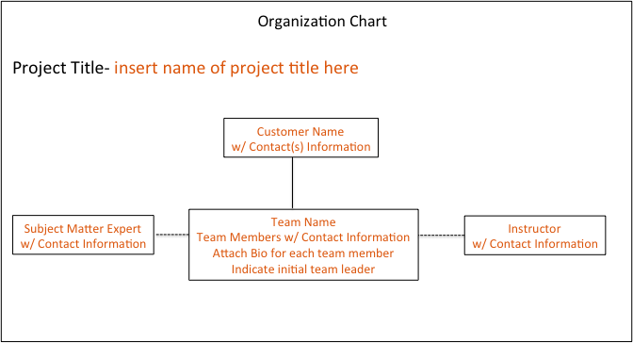

1. Work Breakdown Structure (WBS) Example shown below. Students should construct a WBS that details the project plan. Add additional levels of detail (sub-tasks) to fully define the project plan.



1. Project Schedule Example shown below. Project schedules should align to the WBS.

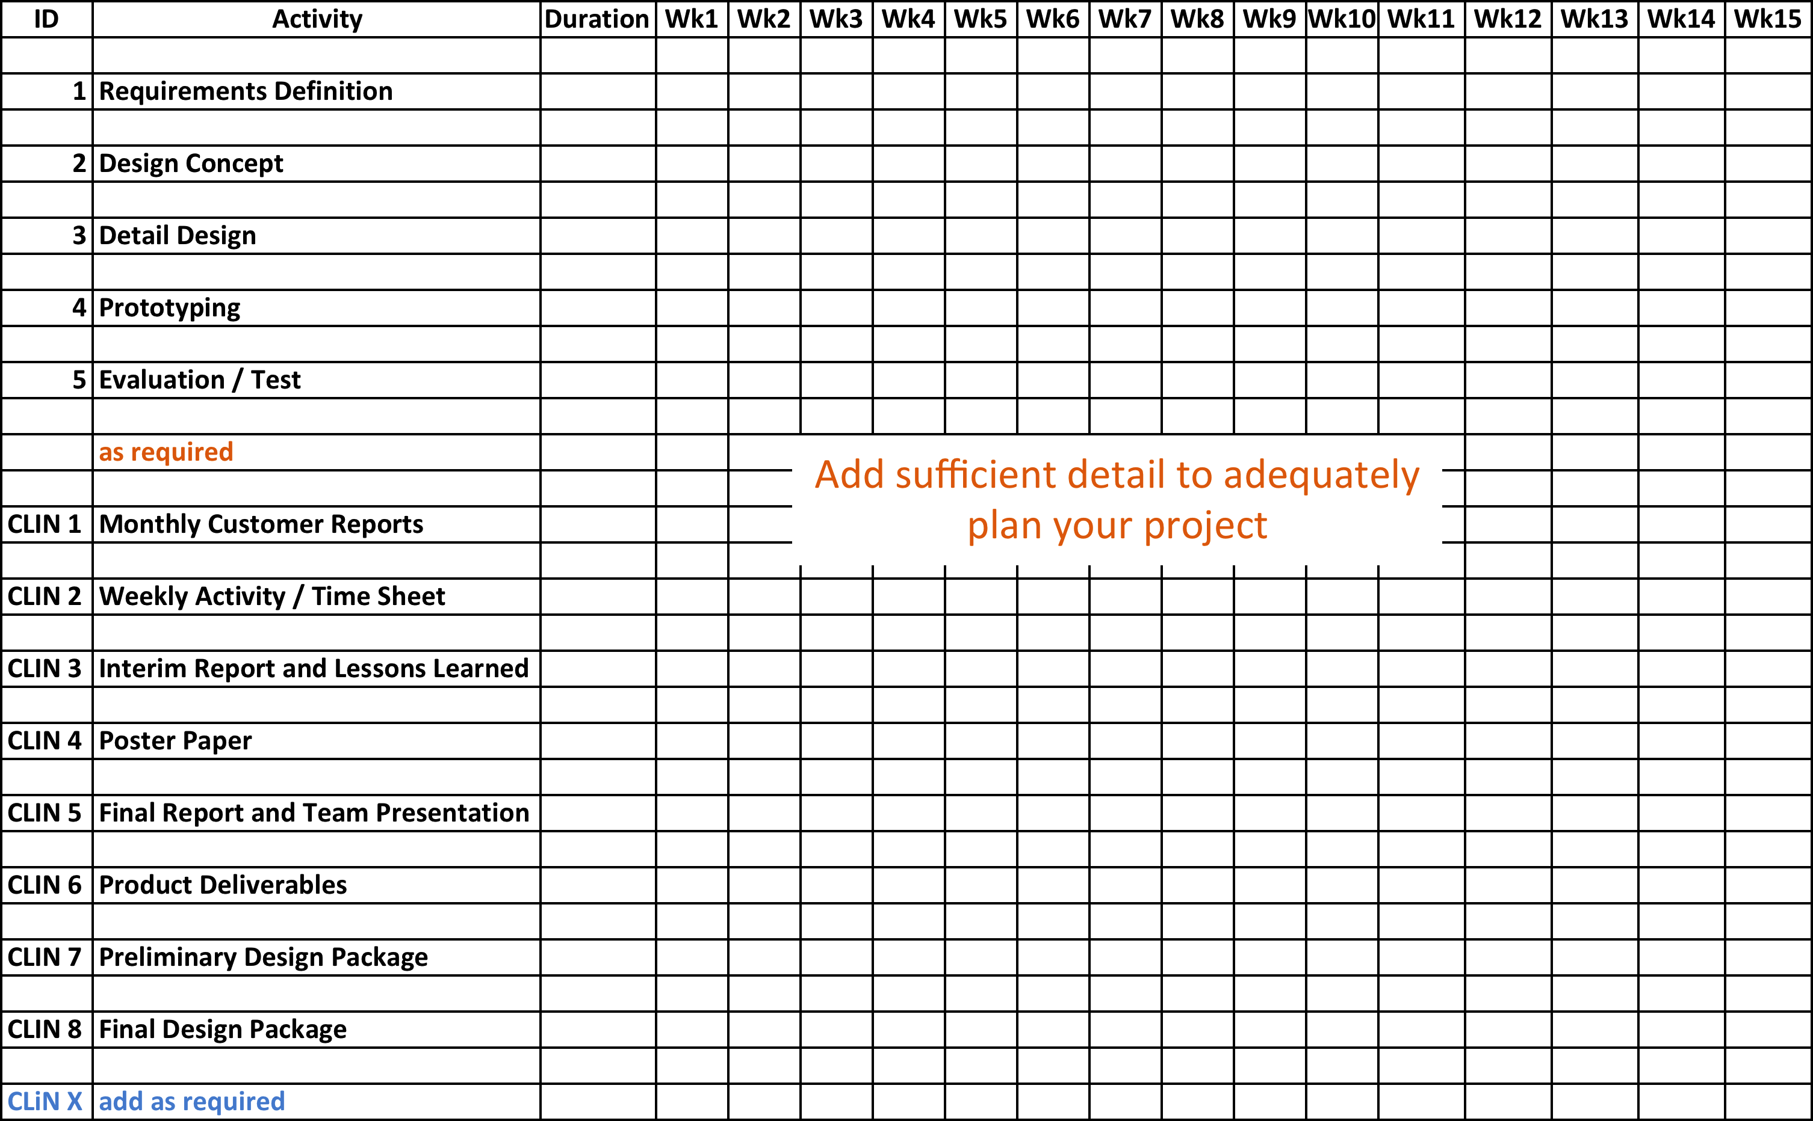

d) Project Cost

1. Weekly projected applied hours (example graph)
2. Estimated non-labor cost items separately.

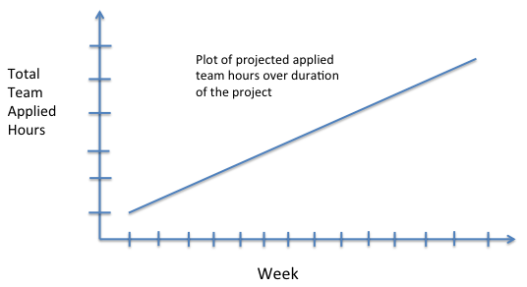

# Appendix A Customer’s Technical Specifications

[Customer Input] Customer to insert any Technical Specifications and Associated Documents necessary to describe the project.